Guide to Safer Streets Near Schools:
Crossing Guards and Student Safety Patrollers
Crossing guards are hired by the Toronto Police Service. The Toronto Police have a Traffic Survey Team that responds to requests for crossing guards. They survey the intersection in question and may make the following recommendations:
- Placement of an adult crossing guard
- Implementation of the School Safety Patrol Program
- Modifications to the traffic control at the crossing location
- Increased traffic enforcement to help control traffic violations
- No change to the existing traffic control already in place

Requests made to the Traffic Survey Team may come from members of the public, Ward Councillors, public officials, school administrative staff and also members of the Toronto Police Service. To make a request, email a letter to officeofthechief@torontopolice.on.ca with ‘Crossing Guard Request’ in the subject line.
In the letter, describe the specific location you wish to be considered for a crossing guard and a brief explanation of why you believe one is needed. Have your letter jointly signed by your School Principal, School Council Chair, and, if possible, sent and/or signed by your Ward Councillor. For more information visit https://www.torontopolice.on.ca/traffic/scg.php
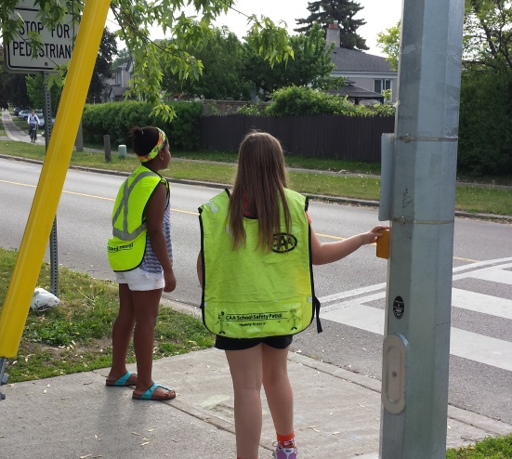
Many schools in Toronto have the Safety Patrol Program, which is a peer based program that trains students 11 years old and up to monitor school crossings. The Safety Patrollers make sure students cross the street safely and responsibly and that the road is clear of dangers before they step out.
Schools interested in starting the Safety Patrol Program can email schoolsafetypatrol@caasco.ca

Additional information can be found at www.caaschoolsafetypatrol.com and www.torontoschoolbus.org/walk/safety-patrol-program

